Book

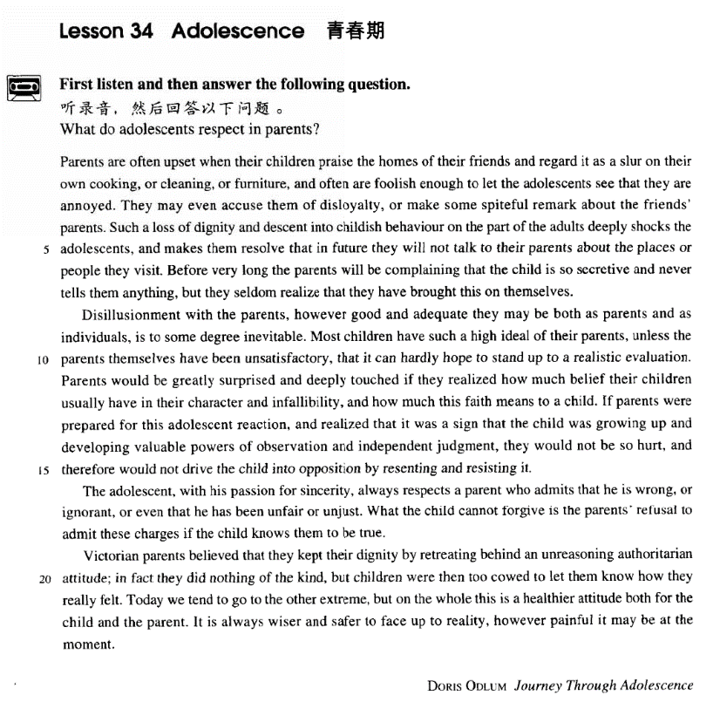

课文

Parents are often upset when their children praise the homes of their friends and regard it as a slur on their own cooking, or cleaning, or furniture, and often are foolish enough to let the adolescents see that they are annoyed.

当家长听到孩子赞扬自己朋友的家时，总感到不安，认为孩子在嫌弃自家的饭菜、卫生、或家具，而且愚蠢地让孩子看出自己的烦恼。

They may even accuse them of disloyalty, or make some spiteful remark about the friends' parents.

他们甚至责备孩子不忠，或者讲些小朋友家长的坏话。

Such a loss of dignity and descent into childish behaviour on the part of the adults deeply shocks the adolescents, and makes them resolve that in future they will not talk to their parents about the places or people they visit. Before very long the parents will be complaining that the child is so secretive and never tells them anything,

家长这种有失身份和孩子气的作法使青春期的孩子大为震惊，决心以后不再向父母讲述去过的地方和见过的人。不要很久,家长就会抱怨孩子守口如瓶，什么事也不告诉他们，

but they seldom realize that they have brought this on themselves.

殊不知这是他们自找的。

Disillusionment with the parents, however good and adequate they may be both as parents and as individuals, is to some degree inevitable.

不管家长的人品有多么好，作为父母有多么合格，孩子们对家长幻想的破灭在某种程度上是不可避免的。

Most children have such a high ideal of their parents, unless the parents themselves have been unsatisfactory, that it can hardly hope to stand up to a realistic evaluation.

除非父母自身不能令人满意，大多数孩子对父母估价过高，以致这种估价很难指望经受住现实的考验。

Parents would be greatly surprised and deeply touched if they realized how much belief their children usually have in their character and infallibility, and how much this faith means to a child.

意识到孩子们的这种信念会对孩子产生多么大的影响，那么家长会大为吃惊和深受感动的。

If parents were prepared for this adolescent reaction, and realized that was a sign that the child was growing up and developing valuable powers of observation and independent judgment,

如果家长对青少年的这种反应有思想准备，并且意识到这象征着孩子们正在成熟和正在发展宝贵的观察力、独立判断力，

they would not be so hurt, and therefore would not drive the child into opposition by resenting and resisting it.

那么他们就不会那样伤心，也就不会由于怨恨和抵触这种反应，而把孩子推到自己的对立面去。

The adolescent, with his passion for sincerity, always respects a parent who admits that he is wrong, or ignorant, or even that he has been unfair or unjust.

青少年酷爱真诚，对于能够承认错误或无知、甚至承认自己做得不分平或不公正的父母，他们总是尊敬的，

What the child cannot forgive is the parents' refusal to admit these charges if the child knows them to be true.

孩子们所不能原谅的是：父母错了，孩子们也看出来了，可是做父母的还不肯承认。

Victorian parents believed that they kept their dignity by retreating behind an unreasoning authoritarian attitude in fact they did nothing of the kind, but children were then too cowed to let them know how they really felt.

维多利亚时代的父母认为，他们可靠无理的权威气派来维护自己的尊严，实际上那是根本不行的。孩子们只不过被吓得不敢让父母知道自己的想法罢了。

Today we tend to go to the other extreme, but on the whole this is a healthier attitude both for the child and the parent.

虽然现在我们倾向于走向另一个极端，但总地来看，孩子和家长双方态度都比较端正。

It is always wiser and safer to face up to reality, however painful it may be at the moment.

遇事采取面对现实的态度总是比较明智和稳妥的，尽管会有暂时的痛苦。

词汇讲解

Lesson 34 Adolescence

adolescence [7ædə'lesns]

n. 青春期

adolescence adolescent

teenager juvenile

juvenile delinquency juvenile delinquent slur [slɜ:(r)]

n.& v. 诋毁，诽谤，中伤

slur n. a remark that is intended to insult someone or damage their reputation 诋毁，诽谤，中伤

regard sth. as a slur on …

He regarded the comments as a slur on his integrity. cast a slur on …

His comments cast a slur on my reputation. slur sb. slander slender regard sth. as a slander on …

slander sb.

Another patient might equally well complain that her neighbours were combining to slander her and persecute her, and yet one might be cautious about believing this statement.

defame sb. traduce sb. libel sb.

slur slurred

a slurred speech of a drunk

blur blurred

a blurred photograph disloyalty [dɪs'lɔɪəltɪ]

n. 不忠实

be loyal / disloyal to one’s friends / country … loyalty / disloyalty

swear / pledge loyalty

Let every nation know, whether it wishes us well or ill, that we

shall pay any price, bear any burden, meet any hardship, support any friend, oppose any foe, to assure the survival and the success of liberty. This much we pledge—and more. To those old allies whose cultural and spiritual origins we share, we pledge the loyalty of faithful friends. United there is little we cannot do in a host of cooperative ventures. Divided there is little we can do—for we dare not meet a powerful challenge at odds and split asunder.

Let every nation know, whether it wishes us well or ill, that we shall pay any price, bear any burden, meet any hardship, support any friend, oppose any foe, to assure the survival and the success of liberty. This much we pledge—and more.

To those old allies whose cultural and spiritual origins we share, we pledge the loyalty of faithful friends. United there is little we cannot do in a host of cooperative ventures. Divided there is little we can do—for we dare not meet a powerful challenge at odds and split asunder.

Let every nation know, whether it wishes us well or ill, that we shall pay any price, bear any burden, meet any hardship, support any friend, oppose any foe, to assure the survival and the success of liberty. This much we pledge—and more. To those old allies whose cultural and spiritual origins we share, we pledge the loyalty of faithful friends. United there is little we cannot do in a host of cooperative ventures.

Divided there is little we can do—for we dare not meet a powerful challenge at odds and split asunder.

accuse sb. of disloyalty

They may even accuse them of disloyalty, or make some spiteful remark about the friends' parents.

royal / royalty

royal espionage

a shop patronized by royalty

O King, be loyal to the royal within you.

— William Shakespeare

faithful / faithless

treacherous adulterous

betray one’s country / principles

Forgetting history means betrayal. spiteful ['spaɪtfəl]

adj. 恶意的，怀恨的

spiteful a spiteful remark

a stream of spiteful telephone calls

evil wicked a wicked plot

malicious

a malicious look in her eyes vicious

the sheriff made suspect by vicious gossip a vicious circle

a virtuous circle

malignant a malignant slander a malignant tumor a benign tumor disillusionment

[7dɪsɪ'lu:ʒnmənt]

n. 幻灭感

illusion

be / live under the illusion that …

Even he still lives under the illusion that country life is somehow superior to town life.

delusion

be / live under the delusion that …

The sick man is under the delusion that he is Napoleon.

The worst thing about the do-it-yourself game is that sometimes even men live under the delusion that they can do anything, even when they

have been repeatedly proved wrong. disillusion

be disillusioned with / by…

Voters are disillusioned with / by the democratic process. be (bitterly) disappointed with / by …

be disenchanted with …

After three divorces he became disenchanted with married life. feel let down let sb. Down

Hey, Jude! Don't let me down.

You have found her, now go and get her. Remember, to let her into your heart.

Then you can start to make it better.

disillusionment

There is increasing disillusionment with the government. infallibility

[ɪn7fælə'bɪlətɪ]

n. 一贯正确

Catholics are required to believe in the infallibility of the Pope. infallible

Even experts are not infallible. fallible

All human beings are fallible. To err is human,

to forgive divine. 凡人多舛误， 唯神能见宥。

― Alexander Pope

fallacy fallacious

fallacious reasoning falsify

fault faultless

flaw flawless

sincerity [sɪn'serətɪ]

n. 真诚，诚挚

sincerity serenity hypocrisy in all sincerity

in all honesty in all frankness in all eagerness

in all probability / likelihood

in all seriousness

History does not relate whether his friend accepted his medical help, but in all probability he did.

造句: 刘备非常诚挚而且非常渴望地三顾 (make a call on sb. / at some

place) 茅庐 (the thatched cottage) 请 (solicit) 诸葛亮出山辅佐。

Liu Bei made three personal calls at the thatched cottage to solicit Zhuge Liang’s help in all sincerity and eagerness.

cow [kaʊ]

v. 恐吓，威胁

cow coward cowardice cowardly / chicken

cow sb. into sth. / doing

The protesters were cowed into submission by the army. He cowed the witness into keeping qiuet.

intimidate sb. into sth. / doing.

intimidation intimation imitation

bully sb. into sth. / doing

The strikers were bullied into dropping their demands. He was bullied by an older boy at school.

school bullies

Parents are often upset when their children praise the homes of their friends and *regard* it *as a slur on* their own cooking, or cleaning, or furniture, and often are foolish enough to let the adolescents see that they are annoyed.

upset adj. unhappy, worried or angry Don’t upset the apple cart.

regard … as a slur on … regard … as a slander on … be … enough to do sth.

be so … as to do sth.

… and are so foolish as to let the adolescents see that they are annoyed. be … enough that …

be so … that …

Although negotiators are optimistic, the details are complex enough that they may be hard-pressed to get a deal at all.

annoy annoyed annoying

accuse sb. of sth.

Dimitri immediately went to Aleko's house and angrily accused him of stealing the lamb.

blame

blame sb. for sth. blame sth. on sb.

They blamed George for the failure. They blamed the failure on George. censure sb. for sth.

Ministers were censured for their lack of decisiveness during the crisis. condemn / denounce

The international community condemned / denounced suicide bombings against civilians.

condemn … for / as …

The movie was condemned for its sexism.

The terrorist attack was condemned as an act of barbarism and cowardice. scold sb. for sth.

His mother scolded him for breaking her favorite vase. rebuke / reprimand sb. for sth.

I was rebuked by my manager for being late.

The manager was most apologetic and reprimanded the assistant severely.

admonish sb. for sth.

The doctor admonished him for too much drinking. make a remark about / on …

Such a loss of dignity and descent into childish behaviour *on the part of*

*the adults* deeply shocks the adolescents, and makes them resolve that *in*

*future* they will not talk *to their parents* about the places or people *they*

*visit*.

her gradual descent into alcoholism His descent into crime was rapid. descend to + n. / doing

descend to fraud descend to abuse

descend to writing anonymous letters

Other people may gossip, but don't descend to their level. on the part of sb. / on sb.’s part

由某人作出的

It was a mistake on my part.

It was a mistake on the part of the authorities.

There is a unanimous demand on the part of the parents for a cut in tuition.

It was not a matter of choice for the traveler or merely a charitable

impulse on the part of the settlers. It reflected the harshness of daily life: if you didn’t take in the stranger and take care of him, there was no one else who would. And someday, remember, you might be in the same situation.

The pursuit of leisure on the part of the employees will certainly not

their prospects of promotion.

[A] spur [B] further

[C] induce [D] reinforce

Teachers' salaries should be based on their students' academic performance.

Write a response in which you discuss the extent to which you agree or disagree with the claim. In developing and supporting your position, be sure to address the most compelling reasons and/or examples that could be used to challenge your position.

I agree with the speaker that it is sometimes necessary and even desirable to relate students’ academic performance to their teachers’ salaries. A contrary view may be condemned as irresponsibility on the part of schools’ administrators for students. Nevertheless, teachers’ performance is not always the main determinant of their students’ academic success and a rigid, indiscriminate wage policy may discourage teachers and end up lowering their students’ grades.

for one’s part 对某人而言

For my part, I prefer living in the city.

Napoleon's army was weakened and the British, for their part, were eager to attack.

in part = partly; to some degree 部分地，某种程度上

The accidents were due in part to the bad weather.

When we use a phrase like 'it serves him right', we are, in part, admitting that a certain set of circumstances has enabled justice to act of its own accord.

Public distrust of scientists stems in part from the blurring of boundaries between science and technology, between discovery and manufacture.

Blacks have significantly shorter life spans, in part due to racism in the health establishment.

resolve a problem / dispute

resolve to do … / that …

decide to do … / that …

in future in the future

Human beings may inhabit other planets in the future.

*Before very long* the parents will be complaining that the child is so secretive and never tells them anything, but they seldom realize *that they*

*have brought this on themselves*. before very long

before too long before much longer before long

He will soon be working in an office.

She would be going to a fancy dress party with her husband. be secretive / close / reticent about one’s past / plan …

He is so close about his past — it seems like he is hiding something. bring sth. to …

I’ll bring your tea to you. bring sth. on / upon sb.

He accused her of bringing disgrace on the family. bring sth. on / upon oneself

I’ve got no sympathy for him—he has brought this all on himself. You deserve it.

You got what you deserve. You’re asking for it.

It serves you right.

It’s of your own making.

As you’ve made your bed, now you have to lie on it.

Disillusionment *with the parents*, however good and adequate they may be both as parents and as individuals, is *to some degree* inevitable.

Disillusionment with the parents is to some degree inevitable. inevitable

Those who make peaceful revolution impossible will make violent revolution inevitable.

— John F. Kennedy

sth. can’t be helped

She can't help the man look for another platter.

She forgot the platter had been broken.

She didn't realize the platter had been broken.

She doesn't want the man to replace the platter.

M: I don’t know how I managed to break that platter. I’ll be more than happy to buy you a new one.

W: Forget about it. Some things just can’t be helped. Q: What does the woman mean?

Answer: (D) She doesn't want the man to replace the platter.

Most children have such a high ideal of their parents, unless the parents

themselves have been unsatisfactory, *that it can hardly hope to stand up*

*to a realistic evaluation*. have a high ideal of sb.

Try to have a high ideal of ourselves. Don’t have such a high ideal of others.

have high / low expectations of sb. / sth.

Most parents have high expectations of their children.

stand up to sth. = withstand sth. 经得起……，经受住…… China has stood up to the Asian financial crisis.

I’m afraid that children today can hardly stand up to hardship. stand up to sb. 反抗某人

The boy dares not stand up to bullies.

live / come up to sth. 符合……，达到…… The restaurant surely lives up to its reputation. live / come up to one’ expectations

The concert was brilliant ― it lived / came up to all our expectations. look up to sb. 尊敬某人

add up to sth. 总计为……

The numbers add up to 100.

face up to sth. = face / confront sth. 面对（某种难题或困境）

China has to face up to the aging problem.

It is always wiser and safer to face up to reality, however painful it may be at the moment.

wake up to sth. = start to realize sth. 开始意识到……

They need to wake up to the impending threat.

Most children have such a high ideal of their parents that it can hardly hope to stand up to a realistic evaluation.

unless the parents themselves have been unsatisfactory

Parents *would* be greatly surprised and deeply touched if they *realized*

how much belief their children usually have in their character and

infallibility, and how much this faith means to a child. have belief / faith / confidence in …

It means a lot to me. It matters to me.

It weighs heavily with me.

It makes a lot of difference to me. how much this faith matters to a child

how much this faith weighs with a child

how much difference this faith makes to a child

If parents were prepared for this adolescent reaction, and realized *that it was a sign that the child was growing up and developing valuable powers*

*of observation and independent judgment*, they would not be so hurt, and

therefore would not drive the child into opposition *by resenting and*

*resisting it*.

be prepared for sth.

be fully / sufficiently prepared for …

We’re fully / sufficiently prepared for the storm. be mentally prepared for …

We have to be mentally prepared for any eventuality.

If parents were mentally prepared for this adolescent reaction …… be prepared to do

= be ready / willing to do

Why people are prepared to tolerate a four-hour journey each day for the dubious privilege of living in the country is beyond me.

Political science class ran overtime. That’s been happening quite a bit lately, hasn’t it? I guess so. Actually, what happens is that a bunch of us hang around for a while after class to talk with our professor and ask him questions. Who is this twentieth century‘s Socrates?

Professor Howl. Have you heard of him? Hum, he does have a good reputation in the political science department. And a well deserved one. The same students who fall asleep in discussion groups and seminars fight for front-row seats in his lectures.

Oh, no. I hope this isn’t catching. You can joke. But it‘s great to have a professor who’s not only interesting but prepared to give up time to students. I know. They are a rare breed. Maybe I should sit in on his class some time. Do you think he’d care? Not at all. Lots of students bring their

friends, and he says he feels flattered.

Political science class ran overtime. That’s been happening quite a bit lately, hasn’t it? I guess so. Actually, what happens is that a bunch of us hang around for a while after class to talk with our professor and ask him questions. Who is this twentieth century‘s Socrates? Professor Howl. Have you heard of him? Hum, he does have a good reputation in the political science department. And a well deserved one. The same students who fall asleep in discussion groups and seminars fight for front-row seats in his lectures. Oh, no. I hope this isn’t catching. You can joke. But it’s great to have a professor who’s not only interesting but prepared to

give up time to students. I know. They are a rare breed. Maybe I should sit in on his class some time. Do you think he’d care? Not at all. Lots of students bring their friends, and he says he feels flattered.

power(s) n. ability

powers of observation / concentration / judgment

After the accident, he lost the power of speech. drive sb. to do …

It was his violent behavior that drove her to leave home. drive sb. to / into sth.

The recession and the hospital bills drove them into bankruptcy. drive the child into opposition

The adolescent, with his passion for sincerity, always respects a parent

*who admits that he is wrong, or ignorant, or even that he has been unfair*

*or unjust*.

She was dying with hunger

The key word to have closer relations with adolescent children is ‘sincerity’.

What the child cannot forgive is the parent's refusal to admit these

charges *if the child knows them to be true*. know sb. / sth. to do

I know him to be very honest.

Victorian parents believed that they kept their dignity by retreating behind

an unreasoning authoritarian attitude; in fact they did nothing of the kind, but children were then too cowed to let them know *how they really felt*. keep / maintain / retain one’s dignity

lose one’s dignity destroy one’s dignity rob / strip sb. of dignity patriarchy

do nothing of the kind say nothing of the kind

I can assure you I did nothing of the kind.

I never said anything of the kind.

But Alfred had deduced that the Danes were no longer fit for prolonged battle: and that their commissariat had no organization, but depended on irregular raids.

*Today* we tend to go to the other extreme, but *on the whole* this is a healthier attitude *both for the child and the parent*.

on the whole by the large generally

It is always wiser and safer to face up to reality, *however painful it may be at the moment*.